**OMAD - A Novel Approach to Early Detection of Brain Tumours**

**Abhay Mathur, Darsh Thakkar, Mahir Madhani, Omar Shaikh, Dr. Nilesh Rathod, Dr. Aruna Gawade**

*Department of Artificial Intelligence & Machine Learning, Dwarkadas J. Sanghvi College of Engineering, Mumbai, India.*

*Contributing Authors:* [*a21.mathur21@gmail.com*](mailto:a21.mathur21@gmail.com)*,* [*darshthakkar09@gmail.com*](mailto:darshthakkar09@gmail.com)*,* [*mahirmadhani@gmail.com*](mailto:mahirmadhani@gmail.com)*,* [*omarraza01@gmail.com*](mailto:omarraza01@gmail.com)

**Abstract.** This research explores how Artificial Intelligence (AI) and Machine Learning (ML) can revolutionize brain tumour detection. Brain tumours are a serious health threat that can affect thinking and movement. Detecting them early is very important because it improves treatment results and increases survival rates. AI is very good at recognizing images, especially in medical imaging, and can make diagnosis more accurate and scientific. In India, about 30,000 new cases of brain tumours are diagnosed each year. These tumours can press on important parts of the brain, so early and accurate detection is crucial. This paper aims to improve brain tumour detection models using large datasets, advanced image segmentation, and deep learning algorithms. It also looks at identifying early symptoms of brain tumours using a technique called epigenetic MRI combined with YOLOv8’s CNN-based architecture, which can improve treatment outcomes. A custom CNN model built with TensorFlow is used to classify brain tumours into three types: Meningioma, Glioma, and Pituitary. To overcome the problem of not having enough training data, a Generative Adversarial Network (GAN) creates artificial MRI scans to help train the model. Using AI and ML improves the accuracy of diagnoses and provides insights into how brain tumours develop and progress, leading to more personalized treatment strategies. This research addresses a major healthcare challenge by using AI and ML to improve brain tumour detection methods. The findings of this paper could transform current diagnostic approaches, leading to better patient care and higher survival rates. The combination of AI and ML offers a promising way to detect brain tumours early and accurately, highlighting a commitment to solving this serious medical issue with innovative solutions.

*Keywords:**Brain Tumours, Early Detection, Medical Imaging, Artificial Intelligence, CNN, YOLO, GAN*

**1. INTRODUCTION**

Artificial intelligence (AI) holds tremendous promise for revolutionizing health innovation. Leveraging AI in image recognition expands our understanding beyond human capabilities, particularly in medical imaging for automatic diagnosis. With AI, diagnostic radiology is transitioning from subjective interpretations to objective and scientific analysis. AI and Machine Learning (ML) have demonstrated immense potential in brain tumour detection, fundamentally transforming how this critical medical challenge is approached. Utilizing advanced deep learning algorithms, along with image recognition and segmentation techniques, AI can surpass human visual capabilities, facilitating the automatic diagnosis of brain tumours from medical images, particularly MRI scans. The importance of early and accurate brain tumour detection cannot be overstated. Timely identification enables prompt intervention, leading to improved treatment outcomes. Brain tumours can be highly dangerous and life-threatening, exerting pressure on vital brain structures and causing various neurological symptoms and impairments. Early detection through AI and ML technologies significantly enhances the chances of successful treatment, contributing to better patient care and improved survival rates. Furthermore, AI's capacity to analyze large datasets and identify patterns in medical images facilitates research, allowing medical professionals to gain deeper insights into brain tumour development, progression, and potential personalized treatment strategies. This ability to process vast amounts of data and extract meaningful patterns provides a robust foundation for developing innovative and effective approaches to brain tumour management, ultimately transforming patient outcomes and advancing the field of medical diagnostics. In addition to its diagnostic capabilities, AI can support other aspects of brain tumour management. For instance, AI-driven tools can help in planning surgical interventions by providing precise maps of tumour locations and predicting potential complications. This enhances the accuracy and safety of surgeries, leading to better recovery rates and fewer post-operative issues. AI can also assist in monitoring treatment efficacy over time. By continuously analyzing follow-up scans, AI can detect subtle changes in tumour size or characteristics that may indicate how well a treatment is working. This allows for timely adjustments to treatment plans, ensuring that patients receive the most effective therapies. Moreover, AI-powered predictive models can forecast patient outcomes based on historical data and individual patient characteristics. These predictions can guide clinicians in making more informed decisions about treatment options and expected prognosis, leading to more personalized and effective care plans. In research, AI's ability to process and analyze large datasets accelerates the discovery of new biomarkers and potential therapeutic targets. By identifying patterns and correlations that may not be apparent to human researchers, AI can uncover new insights into the mechanisms of brain tumour development and progression. This can lead to the development of novel treatments and improved therapeutic strategies. Overall, the integration of AI and ML technologies in brain tumour detection and management represents a significant advancement in healthcare. It not only improves diagnostic accuracy and treatment outcomes but also enhances our understanding of brain tumours, paving the way for more innovative and effective medical practices. As AI continues to evolve, its applications in healthcare are likely to expand, offering even greater benefits to patients and medical professionals alike.

**2. LITERATURE SURVEY**

Adham Aleid et. al [1] conducted research which introduced a classical automated segmentation approach which was meant for early stage brain tumour detection in MRI images. Utilising a multi-level thresholding technique with a Harmony Search Algorithm (HSO), optimised parameters enhance segmentation. Performance, evaluated through Accuracy, Dice Coefficient, and Jaccard index, rivals CNN and DLA methods but excels in execution time and complexity. Future prospects include exploring pixel-based methods to further refine segmentation, aiming for enhanced accuracy and precision in brain tumour detection. Md. Saikat Islam Khan et. al [2] conducted research which introduces two deep learning models for brain abnormality identification and tumour grade classification. The "proposed 23-layer CNN" handles large image volumes, while the "Fine-tuned CNN with VGG16" is designed for limited data, boosted by comprehensive data augmentation. Both models achieved high prediction accuracy (97.8% and 100%) for two datasets, outperforming previous studies. Future directions involve leveraging a substantial dataset for robust models, exploring zero-shot, few-shot, and deep reinforcement learning, and considering additional layers or regularisation techniques for small image datasets in CNN models. Soheila Saeedi et. al [3] conducted a study which utilised a dataset of 3264 MRI brain images, including glioma, meningioma, pituitary tumours, and healthy brains. Preprocessing and augmentation preceded the development of a 2D CNN and a convolutional auto-encoder network, both achieving high training accuracy (96.47% and 95.63%, respectively). Comparisons with six machine learning techniques revealed significant differences in accuracy. The future focus involves exploring robust deep neural networks for swift and accurate brain tumour classification, paving the way for broader cancer detection applications in MRI or CT scans. P Gokila Brindha et. al [4] explores, in their paper, the use of ANN and CNN for classifying normal and tumour brains. ANN operates as a digital counterpart to the human nervous system, with layers of neurons and a training process based on experiential knowledge. The study also incorporates CNN, focusing on image input. The self-defined architectures of both models are compared, revealing that CNN outperforms ANN in predicting brain tumour presence, providing 65.21% testing accuracy. Future optimization techniques could further refine model parameters for enhanced performance. Andronicus A. Akinyelu et. al [5] conducted a survey that delves into brain tumour diagnosis techniques, emphasising CNNs, CapsNets, and Vision Transformers. Despite CNNs' success, they require vast datasets and struggle with rotations. Capsule Networks (CapsNets), characterized by fewer parameters, demonstrate remarkable robustness to rotations. Meanwhile, Vision Transformers (ViTs), leveraging self-attention mechanisms, excel at capturing long-range dependencies within data. Future prospects in medical imaging analysis include developing integrated frameworks capable of handling segmentation, classification, and multi-grade estimation. This entails further exploration of CapsNets and an in-depth investigation into the application of Swin Transformers, which show significant promise in advancing the accuracy and efficiency of medical image analysis.This paper by Amran Hossain et. al [6] introduces an innovative deep-learning model specially made for the classification of brain tumours using reconstructed microwave brain (RMB) images. This model is unique because of its efficiency and low computational footprint, making it perfect for deployment in scenarios which have limited resources. The research team collected a comprehensive dataset of RMB images featuring both single and double tumours, using this dataset to both train and test the model's performance. The outcomes of this study highlight the remarkable accuracy achieved by the proposed model in effectively classifying diverse brain tumours. The paper not only offers a fresh perspective on brain tumour classification via RMB images but also underscores the potential prowess of deep learning in revolutionizing this domain. Within this research, the authors unveil two groundbreaking components: MicrowaveSegNet (MSegNet), a nimble segmentation model proficient in demarcating brain tumours, and BrainImageNet (BINet), an ingenious classifier adept at categorizing the segmented images into distinct brain tumour types. Through meticulous evaluation on a dataset of images sourced from a sensor-based portable microwave brain imaging system (PMBIS), the findings underscore the remarkable accuracy achieved by these novel models in both segmentation and classification endeavors. Furthermore, the paper delves into the shortcomings of existing brain tumour segmentation and classification techniques, while accentuating the strengths inherent in the proposed framework. The study identifies the limitations in current methods, such as inadequate precision and robustness, and illustrates how MSegNet and BINet overcome these challenges by leveraging lightweight deep learning architectures. In summation, the paper unveils a promising avenue for the realm of brain tumour segmentation and classification, capitalizing on the efficacy of lightweight deep learning models. This approach not only enhances the accuracy and efficiency of brain tumour diagnosis but also sets a new benchmark for future research in medical imaging analysis, emphasizing the transformative potential of AI in healthcare. In this study, the authors, Jianxin Zhang et. al [7], present SDResU-Net, a novel FCN-based network for brain tumour segmentation. Integrating dilated and separable convolutions into a residual U-Net architecture, SDResU-Net significantly improves the receptive field, captures pixel-level details, and outperforms existing methods on BraTS 2017 and BraTS 2018 datasets, demonstrating its effectiveness for brain tumour segmentation. In medical imaging, particularly for MRI brain tumour segmentation, the complex variability in structures, shapes, and visual characteristics poses a significant challenge. This research by Mukul Aggarwal et. al [8], introduces an efficient brain tumour segmentation method based on an Improved Residual Network (ResNet) to overcome the computational challenges of Deep Neural Networks (DNN). The proposed approach demonstrates competitive performance, achieving over 10% improvement in accuracy, recall, and f-measure compared to traditional methods like CNN and FCN on BRATS 2020 MRI sample data.

**3. PROPOSED METHODOLOGY**

"OMAD – Brain Tumour Detection" involves the use of machine learning and deep learning models to detect brain tumours in MRI/CT scan images with improved accuracy. The paper also aims to identify and detect possible symptoms of brain tumours at an early stage. The scope of the paper includes the application of the newest unexplored machine learning models for semantic segmentation and object detection in MRI/CT scan images of brain tumours. This involves training these models with professionally validated expansive datasets of such scans. Additionally, the paper involves conducting research on the early symptoms of brain tumours and how their detection can be automated.

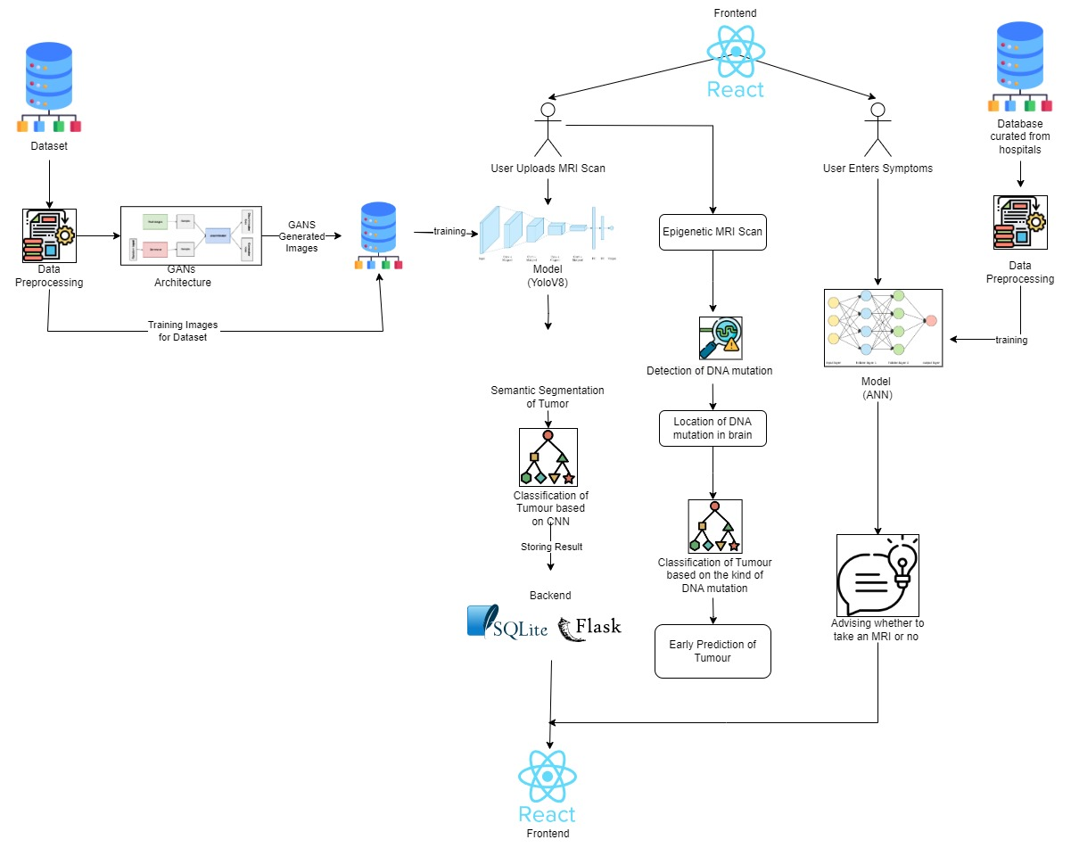

**Figure 1: Architecture diagram**

**3.1 Dataset Selection**

The initial phase involved an extensive search for suitable datasets, leading to the identification of three datasets on Roboflow and one on Kaggle. The Kaggle dataset, named BraTS 2020, stands out as a sophisticated resource specially designed for Brain Tumour detection, emphasising state-of-the-art segmentation methods in multimodal MRI scans. BraTS 2020 focuses on the segmentation of heterogeneous gliomas using multi-institutional preoperative MRI scans. While the 7 GB BraTS 2020 dataset appeared promising, due to computational constraints, the 'Tumour Detection Computer Vision Project' dataset by 'celebal-p3kbm' on Roboflow was opted for as a more feasible alternative for this study. After this it was also needed to look for a Brain Tumour Classification dataset. A dataset was found on Kaggle that classified tumours on the basis of their types: Meningioma, Glioma and Pituitary.

**3.2 Data Pre-Processing**

Siddhartha Bhattacharyya [9], To enhance data consistency and augment the dataset, pre-processing techniques were implemented on the acquired data. This involved scaling images to a standardised resolution and employing data augmentation methods, including omni-directional translation and +45-degree rotation. These not only expanded the dataset but also empowered the model to better discern minute features, thereby improving fitting and accuracy. Erick Rodríguez-Esparza [10] additionally, noise filtering was incorporated through a sequence of a low-pass filter and a Laplacian filter. This approach aimed to facilitate clearer contrast interpretation for the model during the segmentation process.

The low pass filter mask used:

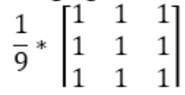

The Laplacian filter used:  
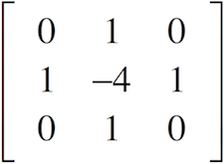

Then, I applied horizontal-flip data augmentation on the brain tumour classification dataset to obtain a larger and more robust coverage of the data features.

The most prominent problem was that it was not possible to gain access to sufficient data to train our model on. Most of the data available was either proprietary or licensed private hospital data and thus inaccessible to us. This problem was overcome by using GAN (Generative Adversarial Network) to artificially generate brain tumour MRI scan datasets using the augmented classification dataset already in possession. The classification model was trained on the GAN constructed and got a much more comprehensive dataset of brain tumour MRI scans.

**3.3 Model Selection & Training**

The research extensively explored various segmentation model architectures, including CNN, Mask R-CNN, U-Net, ViT, and CapsNet. Comparative analysis revealed YOLOv8 as the most promising, boasting high accuracy with its efficient CNN-based design. YOLOv8, renowned for speed and single-shot detection, predicts bounding boxes and class probabilities in a single pass, enhancing localization with anchor boxes. Offering flexibility in versions and backbones, YOLOv8 accommodates accuracy and speed preferences. Subsequently, a Tensorflow CNN model was also trained for classification of the tumour which provides more information about the effects the tumour has on the patient’s body functionalities. Implementing these models, a website was developed featuring a robust React frontend and a Flask backend. Users can upload MRI scans on the frontend, transmitted to the trained YOLOv8 model and a classification CNN model in the backend. Processed results, showcasing segmented tumours outlined in the brain, are then presented on the frontend along with user details in a tabular format. This integration provides a user-friendly platform for efficient and accurate brain tumour detection.

**3.4 The Novel Approach**

The researchers came across a noteworthy research paper detailing the development of Epigenetic MRI (eMRI), a technology facilitating non-invasive imaging of DNA methylation in the brain—a pivotal epigenetic mechanism. Within pig brains, which bear a stronger resemblance to human brains, eMRI uncovered significant regional variations in global DNA methylation, as outlined in the paper. In this study, an advanced eMRI technology is leveraged to identify brain tumours at their earliest, pre-formation stages. By capturing nuanced molecular and cellular changes, this approach is designed for proactive intervention, aiming to revolutionise early diagnosis and ultimately enhance patient outcomes. Functional Magnetic Resonance Imaging (fMRI) is a non-invasive neuroimaging technique that measures and maps changes in blood flow, providing insights into brain activity. During fMRI scans, subjects engage in specific tasks or rest while the scanner detects variations in blood oxygen level-dependent (BOLD) signals. The collected data are then processed to create functional maps, indicating brain regions associated with the performed tasks. The incorporation of fMRI as a novel aspect in this research paper adds a functional dimension to this study. This technique enables the examination of dynamic changes in brain activity, complementing the epigenetic insights provided by eMRI. The integration of both eMRI and fMRI expands the scope of this investigation, offering a comprehensive understanding of brain function and structure in the context of this proactive approach to early brain tumor detection.

**4. RESULTS**

YOLOv8seg, ViT, SAM and UNet models were trained on a brain tumour detection dataset ‘celebal-p3kbm’ from Roboflow and got the following results:

**Figure 5.1** is a Precision-Based Comparative Analysis of YOLOv8 and U-Net for Brain Tumour Segmentation

**Precision:** Precision is the ratio of correctly predicted positive observations to the total predicted positives, providing a measure of the accuracy of the positive predictions made by a model.

**zd**

|  |  |
| --- | --- |
| **Yolov8-seg** | **U-Net** |
| 93.6% | 82.5% |

**Figure, no. 5.1 Precision Results**

**Figure 5.2** shows the YOLOv8 model's training outcomes on the designated dataset, encompassing detailed analyses of all the metrics.



**Figure, no. 5.2 Training Results**

These metrics provide insights into the model's architecture, performance, and evaluation.

* Layers: 195: This denotes the number of layers in the YOLOv8 model, indicating its depth and complexity
* Parameters: 3258259: The total number of parameters in the model, reflecting the learnable aspects and the model's capacity.
* Class: Represents the specific object class, such as "person", "car", or "dog," that the model is designed to detect.
* Images: The number of images in the validation set containing the specified object class, offering an understanding of the dataset distribution.
* Instances: Indicates how frequently the object class appears across all images in the validation set, providing an insight into the prevalence of the class.
* Box(P, R, mAP50, mAP50-95):
  + P (Precision): Reflects the accuracy of the detected objects, specifying the proportion of correct detections.
  + R (Recall): Represents the model's ability to identify all instances of objects in the images.
  + mAP50: Mean average precision at an intersection over union (IoU) threshold of 0.50, assessing the accuracy of "easy" detections.
  + mAP50-95: The average of mean average precision calculated at IoU thresholds from 0.50 to 0.95, offering a comprehensive view of the model's performance across different detection difficulty levels.

**Figure 5.3** shows the results from the validation batch. The confidence score of the YOLOv8 validation batch reflects the model's level of certainty in its predictions, providing a measure of the confidence associated with identified objects during the evaluation process.

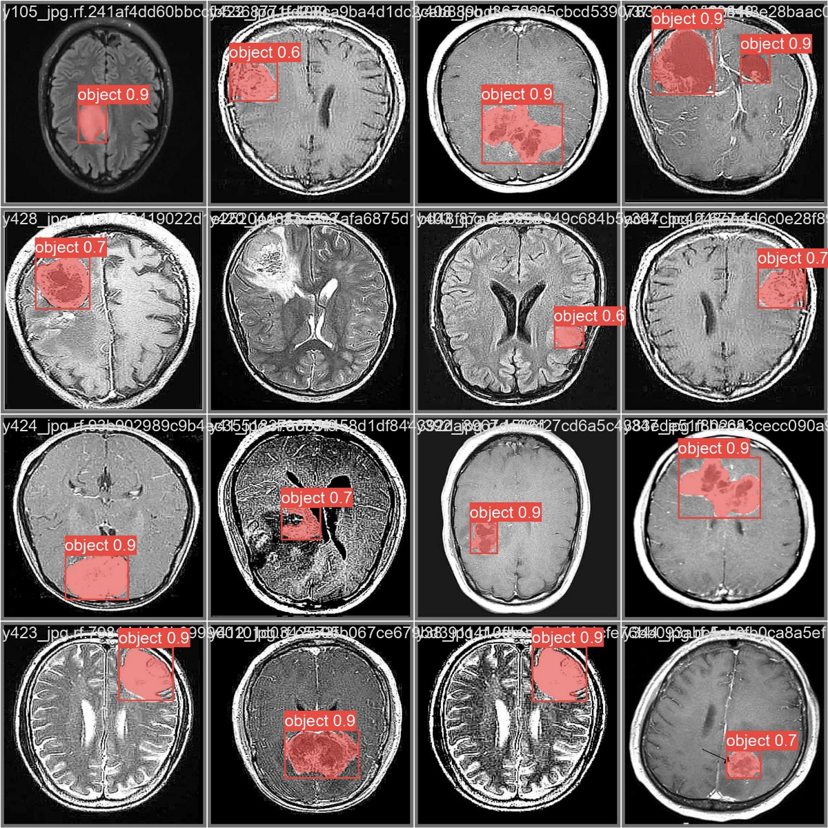

**Figure, no. 5.3 Validation Batch**

The confidence score is calculated using the formula:

C= Pr(object)*IoU

Where,

C = Confidence

Pr(object) = Probability of object

IoU = Intersection over Union between the predicted box and the ground truth.

The probabilities of the boxes are 0.9, 0.6 and 0.7 respectively.

**Figure 5.4** encapsulates a comprehensive visual representation of the evaluation metrics for the YOLOv8 model, providing a graphical overview of its performance outcomes in the context of the research study.

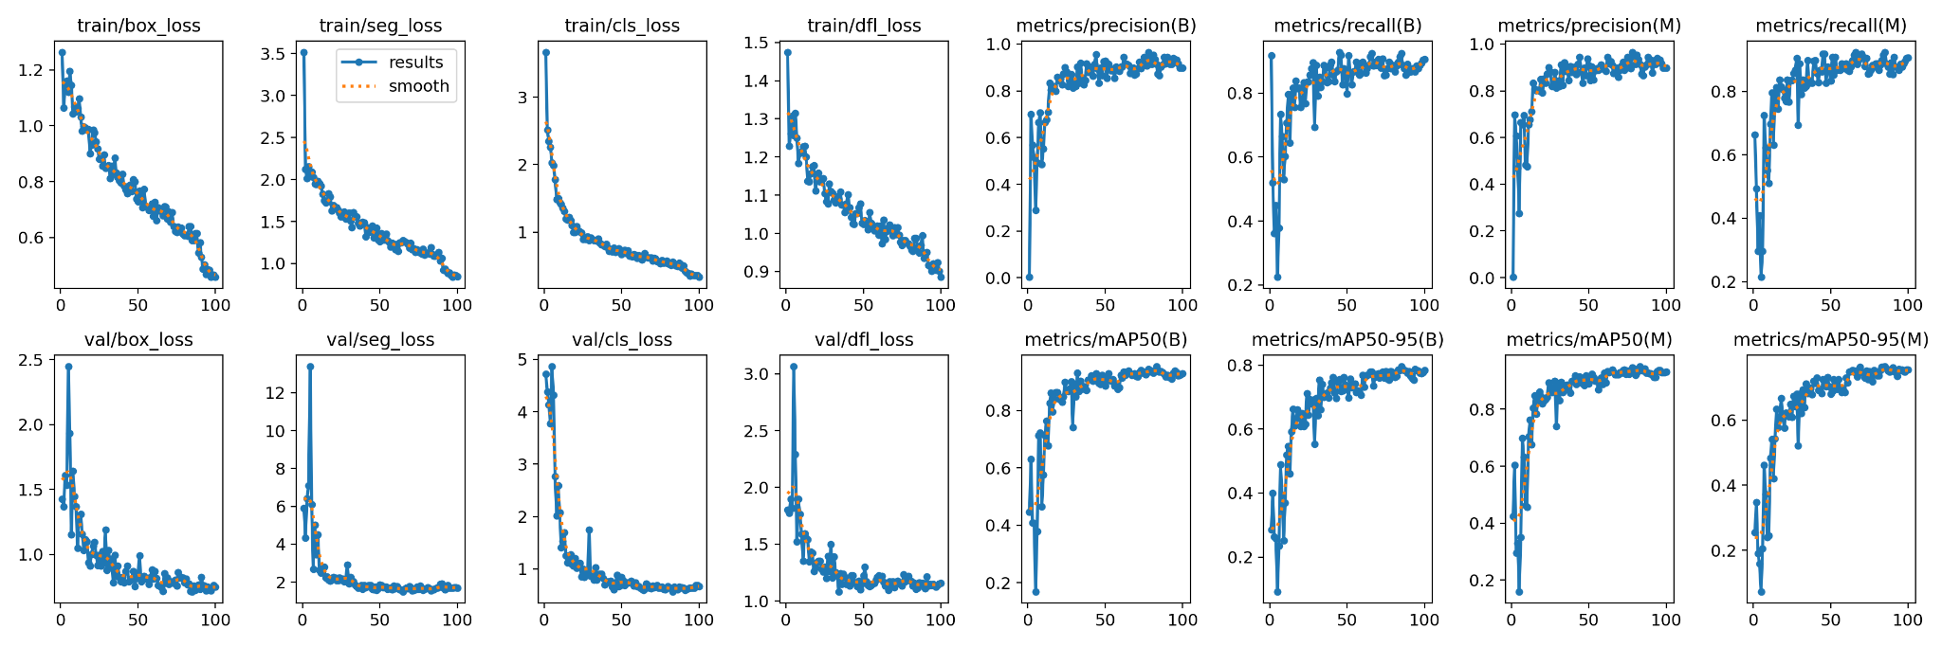

**Figure, no. 5.4 Graphs of Training Results**

**Figure 5.5** illustrates the confusion matrix, showcasing the detailed classification performance of the YOLOv8 model.

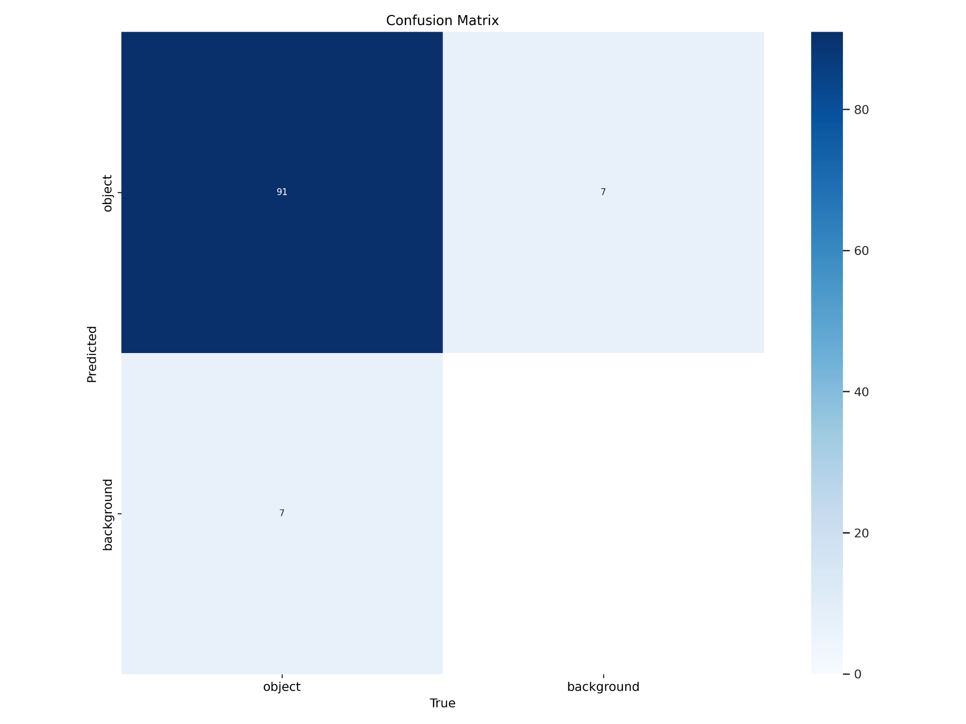

**Figure, no. 5.5 Confusion Matrix**

The confusion matrix provides a detailed view of the outcomes, showcasing the counts of true positives, true negatives, false positives, and false negatives for each class. It provides a summary of the predictions made by the model compared to the actual labels in the dataset. The matrix is a table with rows and columns representing the actual classes and the predicted classes, respectively. Each cell in the matrix represents the count of instances where the actual class matches the predicted class.

**Figure 5.6** illustrates an example of the results obtained on the dataset using the ViT (Vision Transformer) model for a thorough comparative analysis with the YOLOv8 model used.

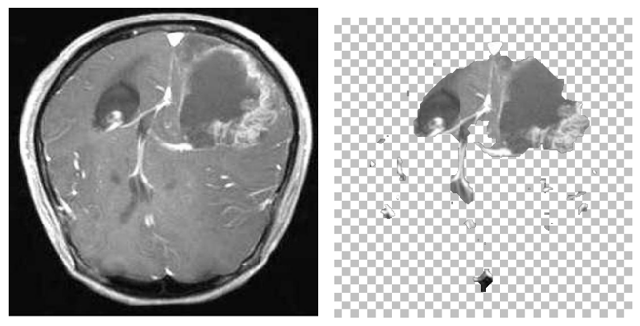

**Figure, no. 5.6 ViT Segmentation Results**

**Figure 5.7** illustrates the images artificially generated by our GAN model after training it on an expansive dataset of brain tumour MRI scans.

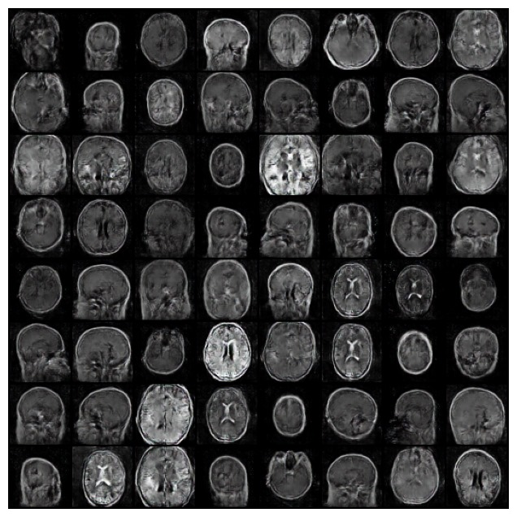

**Figure, no. 5.7 GAN results**

**6. Conclusion**

Brain Tumours are an ever-increasing medical problem and this field has an immense scope of research work in terms of detection automation. After conducting thorough research and surveying multiple articles and papers about brain tumour detection, the conclusion drawn was that the most optimal way to do this is by trying to implement various cutting edge methods and models of semantic segmentation (for eg: YOLOv8 from ultralytics), tumour classification (for eg: CNN) and various new and unexplored Deep Learning models based on the base architecture of Convolutional Neural Networks (CNNs) such as CapsNet. ViT, etc.

Detection of early signs of brain tumours can also be addressed by detecting changes in the DNA of brain cells such as DNA methylation which can be a cause of Brain tumours using Epigenetic MRI scans.

**5. References**

1. Aleid, Adham, Khalid Alhussaini, Reem Alanazi, Meaad Altwaimi, Omar Altwijri, and Ali S. Saad. 2023. "Artificial Intelligence Approach for Early Detection of Brain Tumors Using MRI Images" Applied Sciences 13, no. 6: 3808. https://doi.org/10.3390/app13063808
2. Khan MSI, Rahman A, Debnath T, Karim MR, Nasir MK, Band SS, Mosavi A, Dehzangi I. Accurate brain tumor detection using deep convolutional neural network. Comput Struct Biotechnol J. 2022 Aug 27;20:4733-4745. doi: 10.1016/j.csbj.2022.08.039. PMID: 36147663; PMCID: PMC9468505.
3. Saeedi, S., Rezayi, S., Keshavarz, H. et al. MRI-based brain tumor detection using convolutional deep learning methods and chosen machine learning techniques. BMC Med Inform Decis Mak 23, 16 (2023). https://doi.org/10.1186/s12911-023-02114-6
4. Gokila Brindha, P., Kavinraj, M., Manivasakam, P., & Prasanth, P. "Brain Tumor Detection from MRI Images Using Deep Learning Techniques." _IOP Conference Series: Materials Science and Engineering_ 1055, no. 1 (February 2021):012115.[https://dx.doi.org/10.1088/1757-899X/1055/1/012115](https://dx.doi.org/10.1088/1757-899X/1055/1/012115).
5. Akinyelu AA, Zaccagna F, Grist JT, Castelli M, Rundo L. Brain Tumor Diagnosis Using Machine Learning, Convolutional Neural Networks, Capsule Neural Networks and Vision Transformers, Applied to MRI: A Survey. J Imaging. 2022 Jul 22;8(8):205. doi: 10.3390/jimaging8080205. PMID: 35893083; PMCID: PMC9331677.
6. Hossain, Amran, Mohammad Tariqul Islam, Sharul Kamal Abdul Rahim, Md Atiqur Rahman, Tawsifur Rahman, Haslina Arshad, Amit Khandakar, Mohamed Arslane Ayari, and Muhammad E. H. Chowdhury. 2023. "A Lightweight Deep Learning Based Microwave Brain Image Network Model for Brain Tumor Classification Using Reconstructed Microwave Brain (RMB) Images" Biosensors 13, no. 2: 238. https://doi.org/10.3390/bios13020238
7. Zhang J, Lv X, Sun Q, Zhang Q, Wei X, Liu B. SDResU-Net: Separable and Dilated Residual U-Net for MRI Brain Tumor Segmentation. Curr Med Imaging. 2020;16(6):720-728. doi: 10.2174/1573405615666190808105746. PMID: 32723244.
8. Aggarwal, M., Tiwari, A.K., Sarathi, M. et al. An early detection and segmentation of Brain Tumor using Deep Neural Network. BMC Med Inform Decis Mak 23, 78 (2023). https://doi.org/10.1186/s12911-023-02174-8
9. Siddhartha Bhattacharyya, Ujjwal Maulik, Paramartha Dutta, Multilevel image segmentation with adaptive image context based thresholding, Applied Soft Computing, Volume 11, Issue 1, 2011, Pages 946-962, ISSN 1568-4946, https://doi.org/10.1016/j.asoc.2010.01.015.
10. Erick Rodríguez-Esparza, Laura A. Zanella-Calzada, Diego Oliva, Ali Asghar Heidari, Daniel Zaldivar, Marco Pérez-Cisneros, Loke Kok Foong, An efficient Harris hawks-inspired image segmentation method, Expert Systems with Applications, Volume 155,2020, 113428, ISSN 0957-4174, https://doi.org/10.1016/j.eswa.2020.113428.
11. Juang, Li-Hong and Ming-Ni Wu. “Tumor Classification using Automatic Multi-Thresholding.” Intelligent Automation and Soft Computing 24 (2018): 257-266.
12. Dasgupta A, Gupta T, Jalali R. Indian data on central nervous tumors: A summary of published work. South Asian J Cancer. 2016 Jul-Sep;5(3):147-53. doi: 10.4103/2278-330X.187589. PMID: 27606302; PMCID: PMC4991137.
13. Hollon TC, Pandian B, Adapa AR, Urias E, Save AV, Khalsa SSS, Eichberg DG, D'Amico RS, Farooq ZU, Lewis S, Petridis PD, Marie T, Shah AH, Garton HJL, Maher CO, Heth JA, McKean EL, Sullivan SE, Hervey-Jumper SL, Patil PG, Thompson BG, Sagher O, McKhann GM 2nd, Komotar RJ, Ivan ME, Snuderl M, Otten ML, Johnson TD, Sisti MB, Bruce JN, Muraszko KM, Trautman J, Freudiger CW, Canoll P, Lee H, Camelo-Piragua S, Orringer DA. Near real-time intraoperative brain tumor diagnosis using stimulated Raman histology and deep neural networks. Nat Med. 2020 Jan;26(1):52-58. doi: 10.1038/s41591-019-0715-9. Epub 2020 Jan 6. PMID: 31907460; PMCID: PMC6960329.
14. Mabray MC, Cha S. Advanced MR Imaging Techniques in Daily Practice. Neuroimaging Clin N Am. 2016 Nov;26(4):647-666. doi: 10.1016/j.nic.2016.06.010. Epub 2016 Sep 3. PMID: 27712798.
15. Shah, Faisal & Hossain, Tonmoy & Ashraf, Mohsena & Shishir, Fairuz & Nasim, Md Abdullah & Kabir, Md. (2019). Brain Tumor Segmentation Techniques on Medical Images - A Review. 10.13140/RG.2.2.18685.00486.
16. Nalbalwar, Rajeshwar, U Majhi, Rajesh Patil and Sudhanshu Suhas Gonge. “Detection of Brain Tumor by using ANN.” (2014).
17. Fatih Özyurt, Eser Sert, Engin Avci, Esin Dogantekin, Brain tumor detection based on Convolutional Neural Network with neutrosophic expert maximum fuzzy sure entropy, Measurement, Volume 147,2019, 106830, ISSN 0263-2241, https://doi.org/10.1016/j.measurement.2019.07.058.
18. Kala R. and Deepa P. *, Segmentation of Brain Magnetic Resonance Images using Deep Learning Classification and Multi-modal Composition, Current Signal Transduction Therapy 2020; 15 (2) . https://dx.doi.org/10.2174/1574362414666181220105908
19. Munir, Khushboo & Frezza, Fabrizio & Rizzi, Antonello. (2020). Brain Tumor Segmentation Using 2D-UNET Convolutional Neural Network. 10.1007/978-981-15-6321-8_14.
20. Das, Suchismita, Mahesh Kumar Swain, G. K. Nayak, and Sanjay Saxena. "Brain tumor segmentation from 3D MRI slices using cascading convolutional neural network." In International Conference on Emerging Trends and Advances in Electrical Engineering and Renewable Energy, pp. 119-126. Singapore: Springer Nature Singapore, 2020.
21. Sharif, M.I., Li, J.P., Amin, J. et al. An improved framework for brain tumor analysis using MRI based on YOLOv2 and convolutional neural network. Complex Intell. Syst. 7, 2023–2036 (2021). https://doi.org/10.1007/s40747-021-00310-3
22. Chakraborty, Shouvik, et al. "Intelligent Computing in Medical Imaging: A Study." In Advancements in Applied Metaheuristic Computing, edited by Nilanjan Dey, 143-163. Hershey, PA: IGI Global, 2018. <https://doi.org/10.4018/978-1-5225-4151-6.ch006>